**DR. TŪROA ROYAL ACKNOWLEDGED BY THE NATIONAL IWI CHAIR’S FORUM AT WAITANGI**

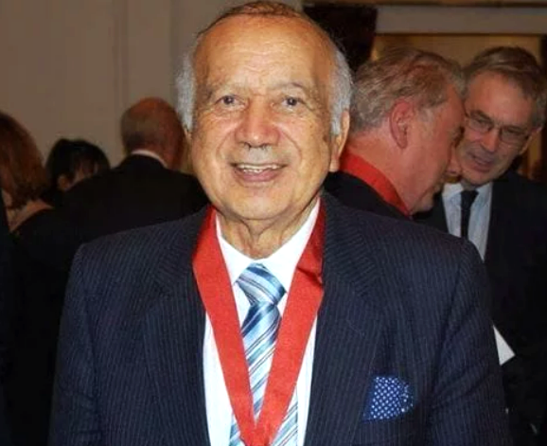

**MEDIA RELEASE**

1 February 2024

At the National Iwi Chair's Forum held at Kerikeri today, Iwi from around the Country celebrated the life and contributions of Dr. Tūroa Kiniwe Royal CNZM. The Forum approved Dr. Royal’s Te Whare Pukenga award in October 2023 but sadly he passed before he could be presented his award. His whānau travelled to Kerikeri to receive the award on his behalf.

Te Whare Pūkenga was established by the Iwi Chairs Forum in 2021 to recognise rangatira who have enhanced the lives of all whānau in Aotearoa through their activities. Specifically the award is given to those whose actions contribute significantly to the revitalisation of the Forum’s values including: Rangatiratanga, Whanaungatanga, Manaakitanga, Kaitiakitanga, Tikanga and Pono. Te Whare Pūkenga is an honour that was conceived by, is managed by, and is completely funded by the Iwi that make up the National Iwi Chairs Forum.

Previous recipients have included Dr. Moana Jackson, Dr. Whatarangi Winiata, Dr. Wally Penetito, Hon. Dame Tariana Turia, DCNZM QSO, Dr Cathy Dewes, Norm Dewes & Linda Ngata. The Forum also acknowledged the contributions of Sir Hirini Moko Mead at their November 2023 meeting and will be attending a special celebration hosted by his iwi later this month in Whakatane.

Tūroa Kiniwe Royal was a Māori educationalist who dedicated his career to improving Māori educational achievement. He was also involved in innovating New Zealand education utilising aspects of Māori language and culture. He has been described as a ‘pioneer Māori educationalist’ and a ‘giant in Māori education’1 .

In 2009, Massey University wrote the following about Tūroa:

*…relatively few have sustained active leadership in the field for more than fifty years. As early as 1956…Mr. Royal was one…who argued that Maori language should be a curriculum subject for teacher trainees. He had by then already embarked on a career that would ultimately facilitate the transformation of New Zealand’s approach to education. By identifying language, culture, and community voice as determinants of successful learning, he was instrumental in building a pathway for educational inclusion…*

Tūroa taught at Tāmaki College and was an Inspector of Māori and Island Education. In 1975, he completed a masters dissertation in Australia which Dr Kathie Irwin stated ‘should be required reading today for people opposed to the spread of te reo Māori.’

From 1978 to 1986, Tūroa was Principal of Wellington High School where he introduced bilingual and whānau-based schooling. From 1986 to 1996 he was Foundation Director of Whitireia Polytechnic, Porirua, and was later appointed Senior Lecturer in Māori Education at Victoria University. From 1981 to 2011, Tūroa was heavily involved in the establishment of Te Wānanga-o-Raukawa, Ōtaki, and he was also a founder of the World Indigenous Higher Education Consortium (WINHEC).

Tūroa was made a Companion of the Queen’s Service Order in 2005 and in 2009 was awarded an Honorary Doctorate of Literature by Massey University. In 2013, he was made a Companion to the New Zealand Order of Merit.

Tūroa Kiniwe Royal was born at Waimangō Point, Hauraki, in 1935. He passed away in late 2023 and returned to Waimangō to be interred in his ancestral urupā.

The National Iwi Chairs Forum recognises his significant contributions to the Nation in education, and in his advocacy for Māori in education and cultural development.

Ends.

For more information:

Charles Royal

Whānau Spokesperson

T: 021 664 907

E: ahukaramu@gmail.com

Daphne Luke

NICF Pou Tikanga

T: 0274 578 713

E: [daphne@taoni.maori.nz](mailto:daphne@taoni.maori.nz)

